Forked the sample-node-app to my public github. Created a Dockerfile and updated the same in github.

<https://github.com/Sanjay-Sanjeev/sample-node-app>

Since mine is windows 8.1, I have used Oracle VM to setup cluster. Using Docker Swarm here to setup a cluster.

Setting up 3 nodes – 1 Master Node and 2 Worker Nodes

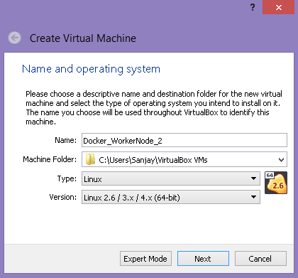

Installing alpine

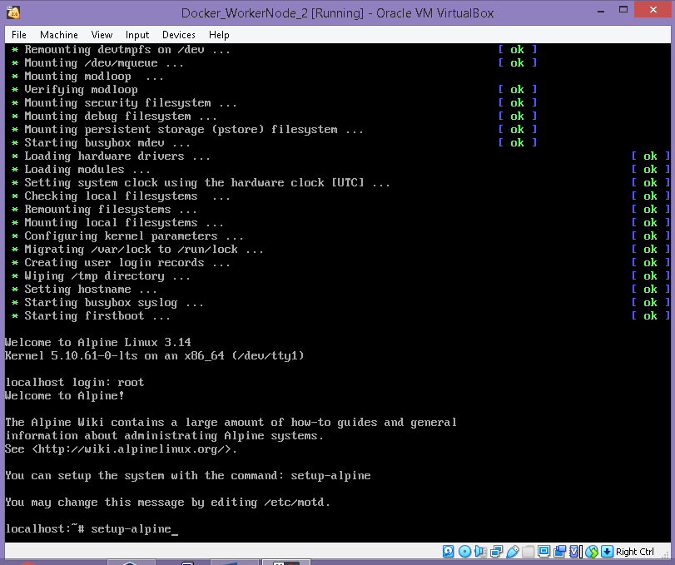

Connected to Putty for ease of working.

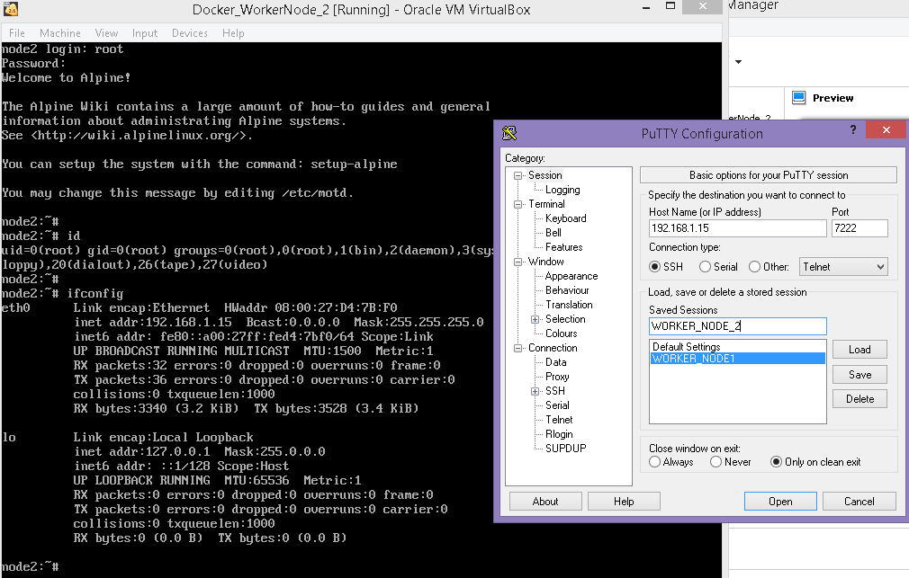

**Installing Docker on the Node**

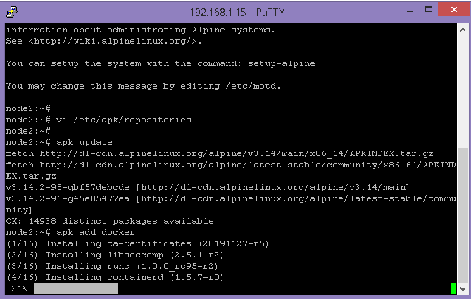

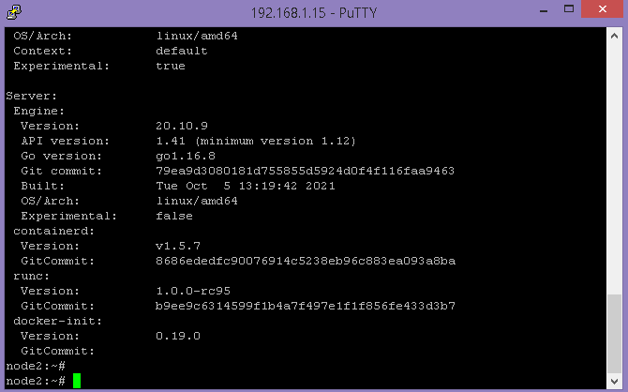

**Similary configured 3 nodes and installed Docker**

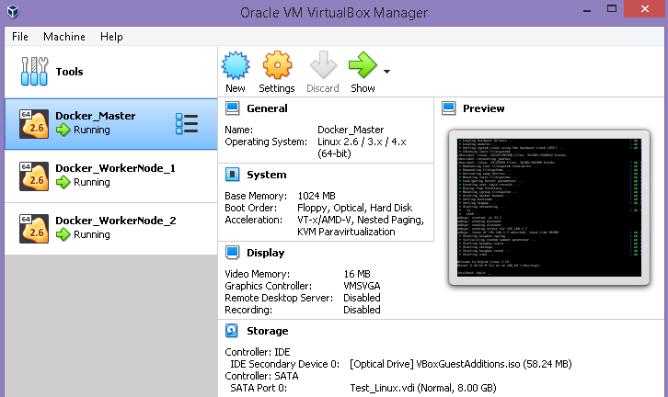

Built the sample-node-app image using the Dockerfile and uploaded the image in the my DockerHub so that I can re-use the image in the containers.

<https://hub.docker.com/repository/docker/sanjaysanjeev/docker-app>

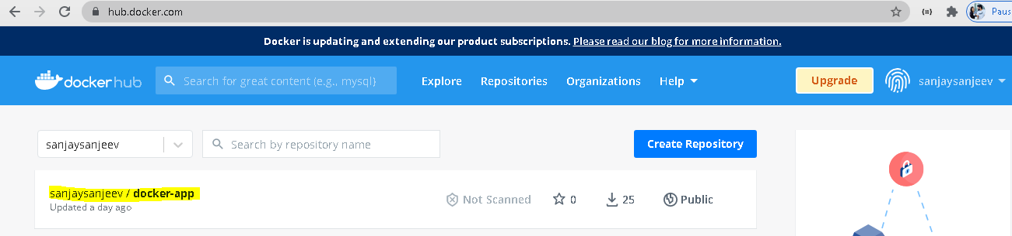

**Setting Master Node**

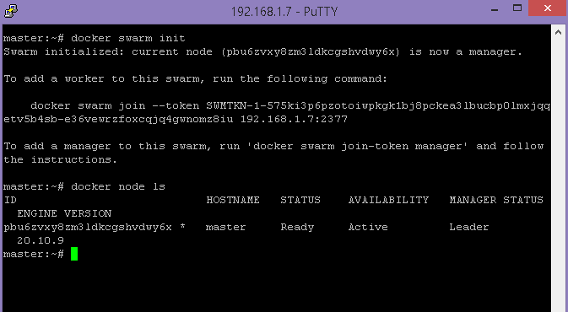

**Adding other two nodes as worker**

**Node1**

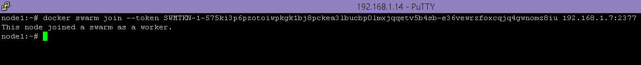

**Node2**

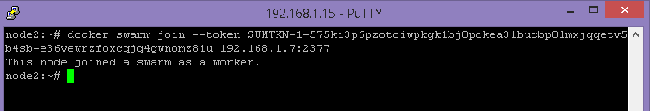

**Cluster setup is ready**

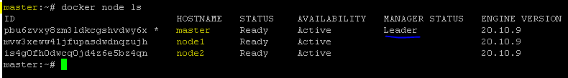

Pulled my image from DockerHub and created a service. Deployment is done on the nodes.

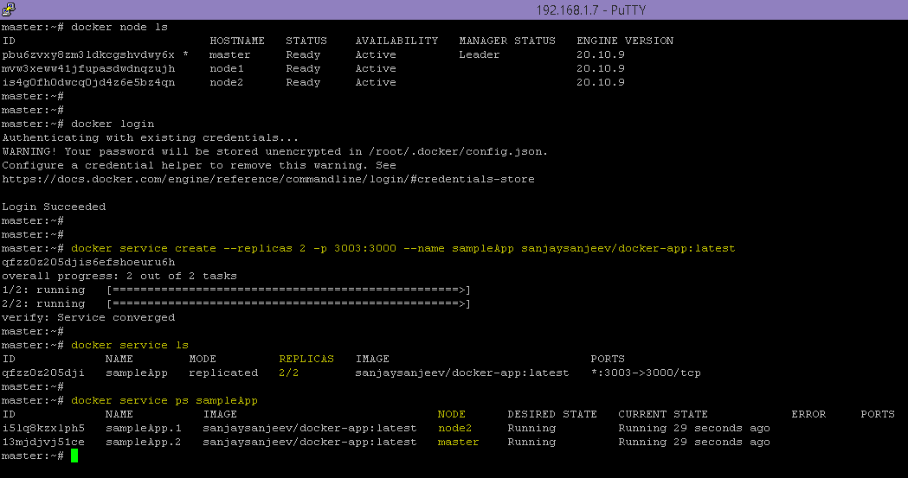

The application got created on Master Node and Node 2.

I want to keep Master node for managing. Hence removed Master node from being worker node by draining.

Removed Master node as a worker node. The service created a task automatically in Node1.

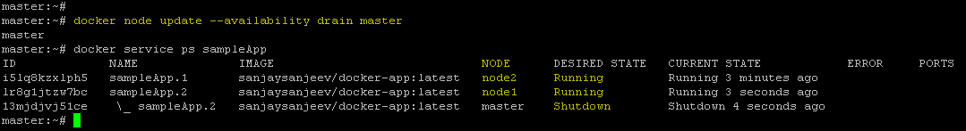

**Node1 : Application running in worker node1**



**Node 2 : Application running in worker node2**

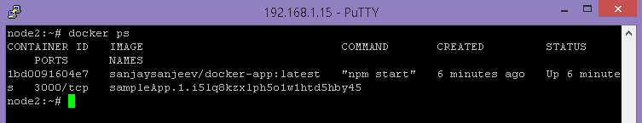

**Accessing Application from Browser**

**Master Node IP :-**

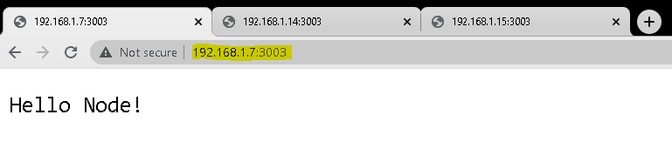

**Worker Node1 IP :**

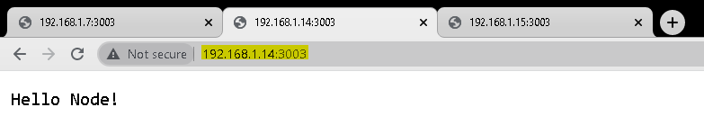

**Worker Node2 IP:**

